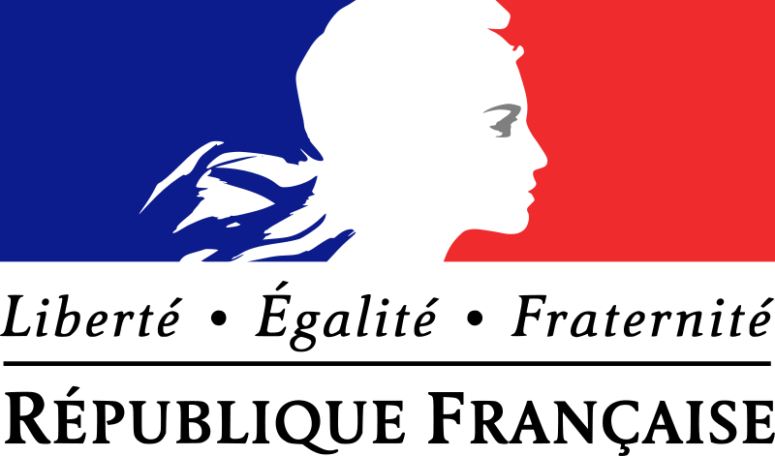
Position Paper of the French Republic
concerning the Proposal for a Regulation of the European Parliament and of the Council on the European Union Agency for Asylum and repealing Regulation (EU) No 439/2010
Initially, the French Republic wishes to express its gratitude to the Commission for developing this great proposal, which represents a great step towards a better asylum policy.
For the problems connected to the increase of applicants for asylum in the Union, the French Republic generally prefers a European solution to national egoism and compartmentalization, as only a European solution can solve the problem in the long run. As President Hollande emphasized several times, the French Republic intends to grant a broad support to the establishment of European agencies in the interest of a unified Europe. We especially support the establishment of the European Union Agency for Asylum, which we consider to be an appropriate tool to deal with the questions that have arisen following last year’s events.
Regarding the tasks of this Agency, the Republic of France particularly wants to emphasize that the monitoring of the correct implementation of the Common European Asylum System is an important task. We are strongly convinced, that the current implementation in many of the member states is insufficient and requires great improvement.
Although the Republic of France generally supports the draft, we whish to suggest the following changes:
Better democratic legitimation of the Management Board
We would propose Art. 39 (1) to be changed in the following way:
„The Management Board shall be composed of one representative from each Member State.“
After „UNHCR“ the following shall be inserted into Art. 39 (2): „and two representatives of the Commission as well as two representatives elected by the European Parliament.“
Art 44 (1) shall be changed to the following: „Except in procedural matters the management board takes its decision with the qualified majority set out in Art. 16 (4) of the Treaty on European Union and Art. 238 (2) of the Treaty on the Functioning of the European Union.“
Art. 44 (2) Sentence 1 as well as Art. 44 (4) are to be deleted.
In Art. 18 (2) „by a three-fourths majority of members with a right to vote“ is to be deleted.
The French Republic wants to raise concerns related to the democratic legitimation of the decisions taken by the management board. The management board has significant competences including the power to place duties on the member states, as for example shown in Art. 18 (2) of the Proposal. That’s why the population of the Union has to be represented in accordance to the democratic standards outlined and agreed upon in the treaties founding the Union. It is also evident that member states contributing a higher share to the common goal should have a higher influence on the affairs undertaken by the Agency.
Also, sending two representatives of the parliament into the Management Board increases the possibility of the Parliament to control its action and exercise influence on its decisions.
Civil Liability
We would propose Art. 26 (1) – (5) to be substituted with the following:
“Where experts of an asylum support team or from the asylum intervention pool are operating in a host Member State, the Union shall be liable as laid down in Art. 240 (2) of the Treaty on the Functioning of the European Union as if the said experts acted as servants of the Union.”
A member state may not be held liable for acts of agents of a foreign state over whom it cannot exercise any influence. In the case laid down in Art. 38 (2) of the proposal, it seems inequitable that the member state trying to help by providing experts in the spirit of solidarity is to be punished for misbehaviour of his agents. Moreover, the question, which state is liable can undermine the cohesion of the union and provoke discords between the member states. The experts do not act in the interest of a particular member state, but, in contrast, in the common interest of the Union as the failure of one state confronted with a sudden arrival of a large number of third state nationals has an enormous negative impact on other member states.
Democratic Legitimation of the Executive Director
Art. 45 (2) and (3) shall be substituted with the following:
“The Commission shall propose a list of candidates to the Management Board from which the Management Board chooses a candidate to be proposed to the European Parliament, following up and open and transparent selection procedures. The proposed candidate shall make a statement before the competent committee of the European Parliament and answer questions expressed by its members. He shall be appointed by the management board only, if the said committee approves to this appointment with the plurality of votes. The Executive Director shall be chosen on the ground of merit and documented high-level administrative and management skills as well as senior professional experience in the field of migration and asylum.”
The position of the Executive Director is very powerful and important. He, therefore, needs to be subjected to sufficient democratic control. The legislative process laid down in Art. 78 of the Treaty on the Functioning of the European Union follows the ordinary legislative procedure, which includes the parliament. It does not seem appropriate, that the parliament should have no influence on appointing the most important agent to carry out the policies on asylum matters, while the member states have a great influence through the management board whose members they appoint. The proposed change therefore implements a minimum of democratic control.
The French Republic hopes, that our very honoured colleges will take these proposals into consideration and engage in a fruitful debate focusing on our common goal and better asylum policy of the European Union.

