Hungary Meuc

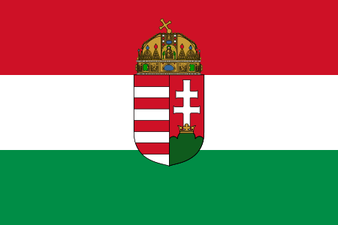
A new mandate for the EU’s Asylum Agency
Hungary - left alone in the asylum crises
Hungary as a transit country was one of the most affected areas in last winters migrant crises. A huge wave of asylum seekers overcame the country. The government agencies were not able to cope with such an amount of migrants. The migrants were in need of water, food and accommodation. Most of them lacked medical care as well. This came along with an increase of the crime-rate and a higher risk of terroristic attacks due to the so called IS who was smuggling terrorists among the asylum seekers. Hungarians felt alienated in their own country.
At this time, especially in the second half of 2015, a European solution was required immediately. Although Hungary tried to encourage the European Union to finally secure their borders and move on to a controlled migration, the European Union failed to find a proper solution. Instead the 28 member states got caught in a fight about who is supposed to take how many migrants. This unacceptable state of political failure forced Hungary to detect an own solution. Instead of just letting the illegal migration happen, Hungary was willing and under compulsion of securing the national borders in order to rebuild the public security.
We reinforced border controls and established an new border security policy with fences to protect the national security. We then were able to control the massive flood of migrants and adopt a controlled immigration again.

Economical and social difficulties facing asylum seekers
Hungary, in comparison to other member states of the European Union, is economical struggling. The country is facing mature issues such as a youth unemployment rate of 14%. We need to concentrate our national revenue on home affairs. Hungary is unable to host asylum seekers due to a lack of financial means. Furthermore Hungary is a rather homogenous country concerning ethnic diversity. The citizens of Hungary are not used to a wide range of ethnic diverse people.
The national identification is disturbed by too many foreigners and will lead to a disruption of social peace. This will end up in a division of society. People already struggling to keep up in everyday life will be left behind since the government is unable to care for the ones in need and the asylum seekers at a time.
Taking everything into consideration, Hungary does not have the capacities to host and feed those who seek shelter.

Hungary’s position to a European solution
Hungary is in favour of the European Union in general, but will not support a European solution concerning the asylum crises. The European Union has failed to arrange a organized system of immigration. Therefore Hungary is concerned about the European Unions project regarding asylum agencies.
Hungary in general is not supporting those plans unless every country is free to decide how to deal with the migrants and how many asylum seekers we will have to take. Hungary is the opinion of, that the more economical powerful countries such as Germany, France and the UK are in charge of taking the vast majority of refugees. Those highly developed countries are financial and society wise able to cope with many asylum seekers. If Hungary is supposed to take refugees as well and therefore taking responsibility among the member states of the European Union, we are not able and not willing to take more then 10,000 Christian migrants.

Conclusion
Hungary has lost trust in the European institutions, due to lack of action. A new stronger mandate for the EU’s Asylum Agency is not that kind of measures, which are needed. National solutions and ways should be possible, Hungary supports stronger border controls. A new stronger mandate would lead to a loss of sovereignty and would mean, that Hungary can not decide whom to take and why.

