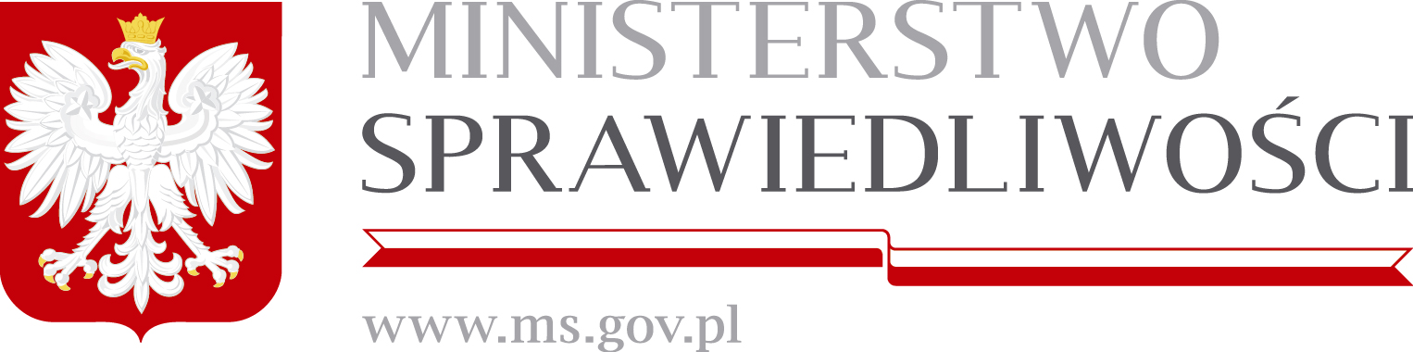

Position of the Republic of Poland
regarding a new mandate for the European Asylum Support Office
The Republic of Poland considers itself a proud member of the European Union. Furthermore, the Republic of Poland considers it a duty to be an active member of the Union built on the principles of solidarity, tolerance and justice.
I. General position on the current migration crisis
The mass migration of recent years demands this very solidarity from all member states of the European Union.
Especially in the light of its own history, Poland is strongly committed to the protection of refugees. The will to protect those arriving at Europe’s shore is not only born out of Poland’s obligations as a member of the EU but arises from the fundamental value of humanity embraced by the Polish people.
We welcome the rules enacted by the EU in the regulations 604/2013 and in the currently discussed regulation for a new mandate for the EASO.
However, we strongly discourage implementing any measures reaching too far beyond the provisions of the Geneva Convention. For this could overstrain individual member states resources both financially and culturally.
We respect the actions undertaken by Germany, Sweden, Austria and their governments in the last year especially considering that their geographical position within Europe did not oblige them to act in this manner.
But the Republic of Poland does not possess the ability to implement a similar policy of openness. We consider this a position we share with a majority of other member states of the European Union.
Poland in particular has a societal and cultural makeup that does not provide for the acceptance of disproportionate amounts of foreigners.
Over the last year Poland has accepted refugees in numbers that if further increased would exceed the reception capacities of our nation tremendously.
II. Specific position on the proposed regulation on the European Union Agency for Asylum
The Polish government welcomes the effective re-establishment of the systems laid out in the Dublin II and III Regulations under a strengthened EASO mandate (cf. Article 6 of the proposal). The agency should concern itself primarily with implementing administrative infrastructure in the member states where refugees are arriving in order to ensure efficient, effective, and lawful asylum proceedings within those states.
Doing so would remove the obstacles pointed out by the ECJ (C-411/10) that are currently preventing member states from returning asylum seekers back to the countries where they first entered the European Union. Otherwise the enforcement of the law in force (e.g. Dublin II and III) is impossible and the states of central Europe cannot be relieved of the pressure they are under.
Furthermore, the Polish government supports that the EASO will be a wholly European answer to the refugee crisis financed entirely with EU-funds (cf. Article 49 III of the proposal). Thus withdrawing the management form the sphere of singular member states. This will lead to a unitary and long-term solution. This will hopefully prohibit further unilateral actions.
The Polish government strongly objects to Article 2 I lit. h. Though the proposal of the regulation only concerns itself with “assistance” the Commission has emphasised in section I.2 that it views and amendment of the Dublin Regulation as one of the priorities of a new asylum system. This amendment aims to implement either a “corrective fairness mechanism” or “a new system based on a distribution key” (Com 2016 197). We reject both of these suggestions. Such a system could not be implemented in Poland for the reasons mentioned above which are applicable to many other members of the EU. Thus we propose striking Art. 2 I lit. h from the mandate as it would be the first step towards a detrimental and unenforceable system of distribution. Besides the impossibility of enforcing such a system due to social and cultural differences such a system is unnecessary. The mass migration Europe is currently experiencing is a phenomenon restricted by time. The goal of refugee reception must not be the permanent integration of refugees into society but much rather to provide them with a safe haven for a certain amount of time until the issues in the countries of origin which constitute grounds for asylum have been resolved.
Even though we oppose the distribution of refugees the Polish government does not abandon the principle of solidarity. Hence, the recipient countries must be relieved of their burden through financial aid by the European Union as outlined in Art. 78 III 1 TFEU.
Ultimately, the European Union should strive towards establishing a number of treaties with the Mediterranean countries of North Africa to guarantee control over the influx of refugees into Europe, and their resettlement.
The agreement between the EU and Turkey reached on March 18th should serve as an example for those treaties.
Abiding by the fundamental principles of the EU, especially democracy and solidarity, a system of distribution cannot be enacted against the will of the majority of member states. Much rather solidarity should be expressed through financial support of affected countries.

