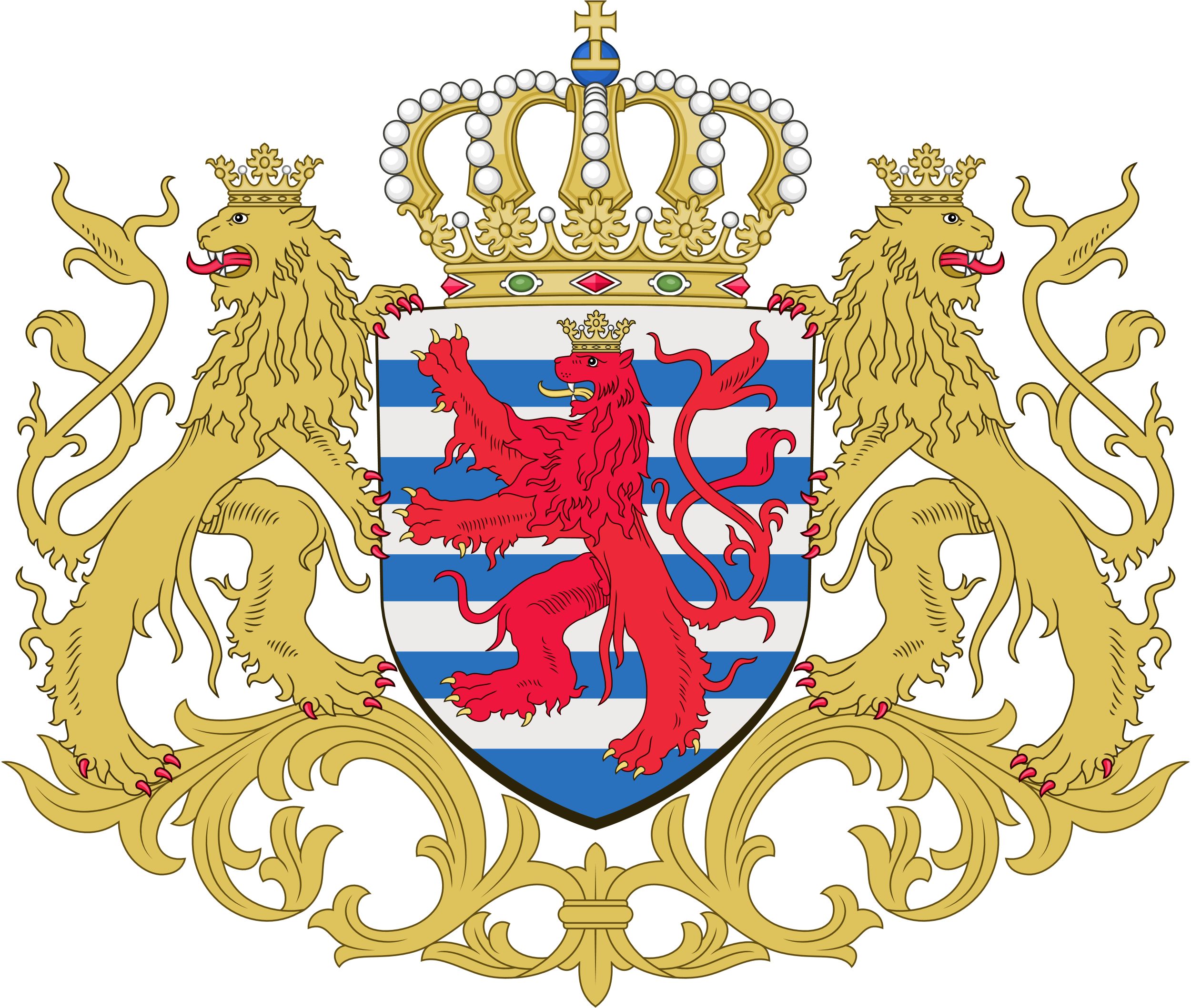
Luxembourg, June 2, 2017

Position Paper of
The Grand Duchy of Luxembourg
On the topic of

A Charter of Digital Fundamental Rights of the EU

Simon Willaschek and Jakob Hach
Representatives of the Grand Duchy of Luxembourg

I. Introduction
As one of the founding members of the European Union, the Grand Duchy of Luxembourg stands strongly in its commitment to the shared values of Europe cooperation and human rights. As a side effect of the rapid digitalization of our world, these values are endangered now more than ever. They must not be pushed aside, but strengthened and renewed. Thus, we, the representatives of the Grand Duchy of Luxembourg, support the addition of a Charter of Digital Fundamental Rights of the European Union (henceforth: The Charter) to the Treaties of the European Union.

II. On Existing Fundamental Rights
It is imperative that the internet does not evolve into a space of lawlessness. Thus, we fully support the implementation of provisions protecting the foundations of our Union: Human dignity, freedom, security and privacy. These principles, as lain down in Articles 1 – 5 and Article 10 of the Charter, must be recognized as the foundation of all public exercise of power. Nevertheless, we believe they constitute an unnecessary duplication, as they are already sufficiently protected under the Articles 1, 8, 11 and 20 of the Charter of Fundamental Rights of the European Union, as well as the constitutions of the individual member states. Thus, we propose to clear the Charter of those provisions merely constituting a repetition of previously existing rights and liberties.

III. On the Access and Use of the Internet
It is our position that free access to the internet as well as the principle of net neutrality form the basis of social participation and economic development in the digital world. The Chamber of Deputies of Luxembourg has voted to enshrine net neutrality in national law. Parliament and the government of Luxembourg will support its protection under European law.
To ensure the safe and responsible use of digital services, we believe a basic education in the principles of the internet is imperative. The integrity of all communications systems and data security must be protected. Nevertheless, we do not see the necessity of codifying these principles in the Charter, as they can be secured much more effectively through simple legislative action.
IV. On the Economic Implications of Digitalization
We are convinced that the achievements this Union prides itself on are not only based on, but rooted solely in a commitment to a single market – free and harmonized. The Charter, aiming to protect fundamental rights in the digital age, therefore must aim to ensure the freedom of the market. Personal liberty is unthinkable without a free market, even more so in the international, borderless internet. Consequently, the Grand Duchy of Luxembourg cannot support statutes that seek to limit economic freedom and consequently personal liberty, as is the case in the current article 1 section 3 and article 17 sentence 3 of the Charter.
Another pillar of the free common market and thus the Union in its entirety is the guarantee and protection of private property. In the digital age, as big data becomes increasingly important for the economy, the concept of property must be broadened: Data must enjoy the same protection as physical property. Thus, we oppose the severe limitation imposed on this principle in Article 9 Section 2 of the Charter. Just as it cannot be expected of natural persons or legal entities to relinquish control of their physical holdings, their data sovereignty shall not be infringed upon. We believe Article 13 shall guarantee this oldest of basic rights: The right to one’s property.
Personal and economic liberty in the European Union are also based on the contractual freedom of each of its citizens. It is vitally important that all Europeans retain their right to freely enter contracts and obligations digitally and to dispose of their property and rights as they see fit. This includes agreements concerning the collection and use of personal data. We deem it unfeasible that European citizens should be limited in these personal liberties as a result of article 11 section 4.

V. On the Social Implications of Digitalization
The fast-paced technological developments entail immense changes to our societal structures. We support all attempts to secure the internet as a liberal, democratic space, as it is in that form all can profit from the full potential of digitalization. The dangers of excessive regulation should not be installed in the Charter, as they hinder the achievement of this goal.
As the process of digitalization advances, evermore branches of our economic system will become obsolete. To ensure a prosperous and peaceful Union, the social question posed by this development needs a feasible answer. We believe the best way to ensure the livelihood of all citizens is through economic growth and innovation, which create new jobs replacing traditional industrial workplaces.

VI. On State Use of Technology
As digitalization progresses and its uses proliferate, states employ technology in an increasing number of areas, be it for administrative reasons or security purposes.
The vital role which the administrative bodies of the EU and its member states play in the protection of data must therefore be recognized. They gather information needed to provide their citizens with numerous public services. However, it would violate the guarantees of privacy and property to make this information available to the public. We find the guarantee of privacy to be contradictory with the commitment of administrative bodies to absolute transparency. This results from Articles 7 and 11 section 1, which stand in opposition to Article 9 Section 1. The Grand Duchy of Luxembourg would support a version of the Charter which avoids this contradiction by allowing state agencies to ensure the secrecy of their citizen’s data.
The use of new technologies by law enforcement agencies or the military must be subject to a strict legal foundation and rigorous control by democratically legitimate institutions. The sovereignty both of other states and of private actors shall be protected and respected.

VII. Conclusion
In conclusion, it is the position of the Grand Duchy of Luxembourg that the Charter of Digital Fundamental Rights of the European Union shall not constitute a duplication of individual liberties already guaranteed, but rather serve as a means of ensuring equal access to, fair interaction within, and constructive use of the digital space.

