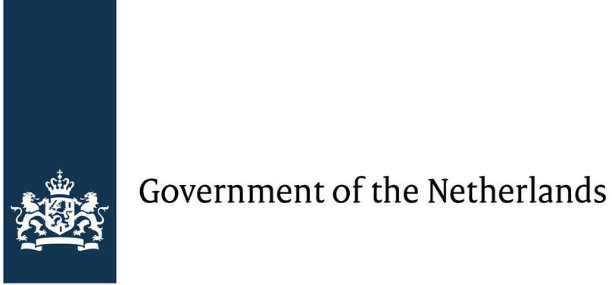

Position Paper of the Dutch Delegation concerning the Proposal for a Charter of Digital Fundamental Rights of the European Union

- Introduction – Analysis of the current situation

Digital technologies have changed the way billions of us live, work and communicate today. But with the new advantages and possibilities brought to us by these technologies, they also pose new risks, challenges and the concern that this technologies will be misused for human rights violations, such as mass surveillance, profiling or something as simple but serious as bullying on the web. As the investigations around the last presidential elections in the United States have shown, digital technologies might even be capable of influencing elections and by doing so they threaten to undermine the fundamental concept of our democracies. Whether this is done by spreading Fake News on the internet, by the use of social bots or technologies we do not even know of, it appears to be absolutely overdue to come together as Europeans and to find ways which can guarantee fundamental rights to the citizens of our countries and to protect our sovereignty and democratic political culture from outside interference and cyber-crime. Since there are no frontiers in cyberspace, it is absolutely clear that guaranteeing fundamental digital rights to its citizens cannot only be a task for a national government anymore, but has to be tackled on an international level. How difficult this can be have shown various international summits in the last decade, where national leaders could not come up with a combined effort, let alone solution. On the other hand, the European Union, despite its current flaws, has proven to be effective in implementing European standards and guaranteeing these standards to be upheld. Therefore, we believe it to be the right platform to ensure fundamental digital rights to European citizens.
Hence, the delegation of the Netherlands is delighted to come together with its fellow European partners to discuss matters of such great importance to our future and the future of rule of law in the digital age.

- Initiatives and summits in the Netherlands
Also in the Netherlands initiatives have been formed and summits have taken place trying to work towards a charter for digital fundamental rights and raise awareness on that matter. “Bits of Freedom” is one of those aforementioned initiatives. It is the leading digital rights organization in the Netherlands focusing on privacy and freedom of communication online. The main focus of Bits of Freedom in particular is to collect and spread information and moreover influence legislation. What is more, the organization did also take part in the campaign “WePromise.eu” that sought to bring digital rights to the agenda of the European elections in 2014. The campaign was supported by 36 different civil rights organisations and activist from all over Europe. Additionally, Netherlands Committee of Jurists for Human Rights is part of the Liberties initiative, which is a non-governmental organisation promoting the civil liberties in the European Union also focusing on the issue of digitalization.

- Netherlands take on the proposed Charter of Digital Fundamental Rights

Unfortunately, there are several points of concern for the government of the Netherlands regarding this Charta. The most important ones are enlisted below.
There are some general points of concern for the delegation of the Netherlands. First of all, we are not convinced whether the right format was chosen. What we mean by that is that there already exists the Charter of Fundamental Rights of the European Union, which guarantees the protection of fundamental rights. It is not clear to us why there should be a second Charter on the same topic with the small difference that these rights only address the digital world. Hence, we believe it would be best to estimate how fundamental rights are already protected by the existing Charter and where these rights should be advanced to suit the digital age. To give an example of where the two charters overlap, we cannot make out a fundamental difference between what is stated in Art. 5 I in the draft on digital rights and Art. 11 in the already existing Charter of Fundamental Rights. Furthermore, we believe that an article of a charter for fundamental digital rights should not include justifications or explanations on why they are part of that charter. The aim should be to create articles that are as timeless and broad in a way that they are applicable to many different situations and adaptable to changes the digital world and society will undergo.
In addition, we believe that a point of discussion should be on what level the protection of fundamental digital rights should be enforced and how to do so.
To express our concerns on two more specific examples, Art. 5 seems to be inadequately formulated. We wonder, how the second paragraph shall be implemented and how the terms ‘digital harassment’ and ‘mobbing’ are being understood and defined.
Moreover, Art. 15 might compromise the fundamental rights of internet companies for the price of trying to achieve sufficient protection for people. A regulation like this could make the traffic of goods and online sales difficult, since companies would have to rely on good faith that their goods and services are being paid for, because they would lack access to basic customer information.

- Conclusion

In conclusion, the Delegation of the Netherlands wants to thank the German initiative of the Zeit Foundation and Gerd Bucerius for their draft of the ‘Charter of Fundamental Rights of the European Union.’
The Netherlands is a country that is aware of the challenges and risks, but also opportunities the digital age is posing. Therefore, the Netherlands is willing to take appropriate action in order to guarantee the safety of the European citizens when interacting in the digital sphere. However, we have to admit that we are not totally convinced whether the ‘The Charter of Fundamental Digital Rights’ is a step in the right direction to ensure our common goal. Thus, we are looking forward to revise the draft of “The Charter of Fundamental Digital Rights” in collaboration with our European partners and we are hoping to be able to present crucial improvements in order to guarantee fundamental digital rights to European citizens.

By order of the government of the Netherlands,

Leila Klamroth and Simon Lautenschläger

Retrieved from: https://www.government.nl/
https://www.bof.nl/english/
https://www.wepromise.eu/en/page/about
http://www.liberties.eu/en/organisations

