Debate on Concession Directive successful
The representatives of the EU Member States reached an agreement or rather compromise about a common regulation of concession contracts and passed an proposal on the award of concession contracts.

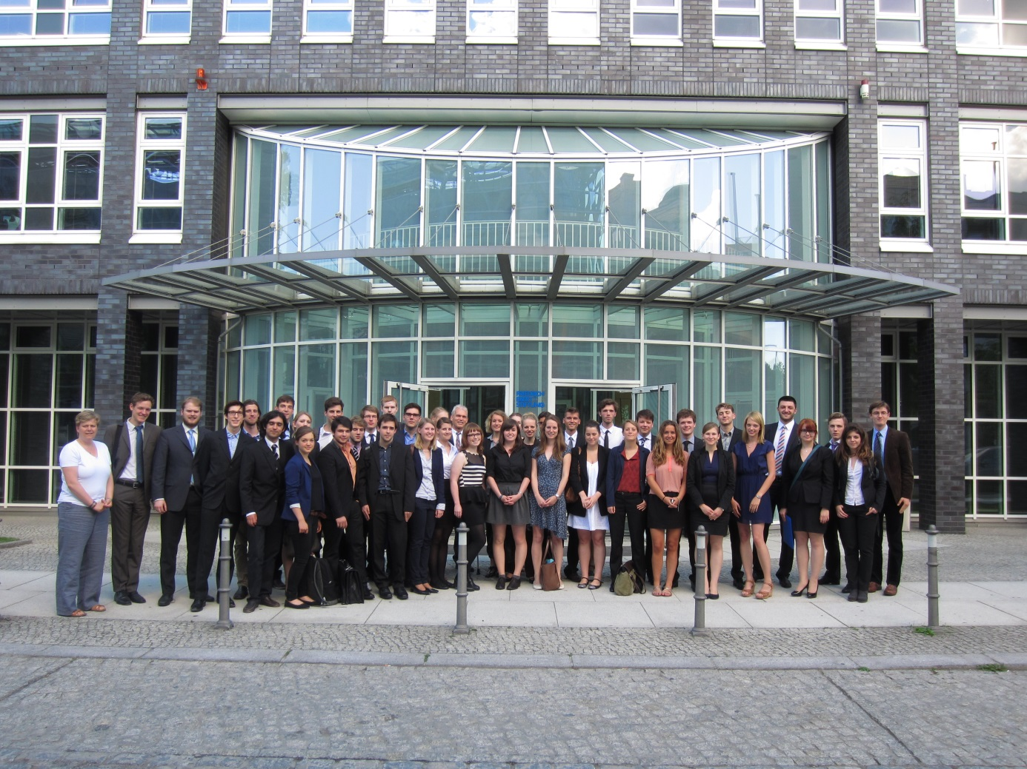
All Ministers in front of Friedrich-Ebert-Stiftung, Hiroshimastraße 28, 10785 Berlin.

The European Union is exposed to an incessant process of expansion and progress. Process depends on cooperation and agreements. To ensure a common process and for prevent the European Union and his Member States from breaking up, it seems to be essential to reach a common sense in all important topics, e.g. economy and a working single market. Particularly in times of economic difficulties and severe budgetary constraints in many EU Member states, the need for common standards and rules becomes more and more evident. Therefore, the European Commission felt forced to act and respond. The Commission drafted a proposal for a Directive of the European Parliament and of the Council on the award of concession contracts, so called Concession Directive.
On the 21th and 22nd of June 2013, the Ministers of the European States assembled in the European Council to discuss and debate on this directive. Its aim was to clarify all difficult items being pointed out before and to underline the supposed necessity of such a regulation.

The first conference day started with an inaugural address by Dr. Matthias Wendel (Maître en Droit) and Yvonne Lehmann (Referent at Friedrich Ebert Stiftung). After the Irish Presidency has opened the official discussion, all Member States pointed out their positions. The first period showed in how far the Member States or rather the Ministers are willing to create a compromise solution. The Austrian Minister stated clearly his doubts with regard to the principle of subsidiarity, in his opinion the debate “[…] is easy to answer: No!”. He clarified that the possibility of regulating and distributing concessions has to remain by the local government. Right from the beginning of the discussion, the Austrian Minister strictly blocked any attempts to come to a rapprochement between those states who were in favor of this direction and those being still doubtful. However, the European Commission insists that “[i]t is necessary to close a gap in the single market and to eliminate case law”. The Czech Republic also emphasized the great need of concession contracts because of different quality standards in the Member States. “We have to create and develop a European Quality Standard of water” , underlined one of the Czech Ministers. Most of the Member stated confirmed the necessity of a directive concerning concession contracts, but mentioned several objections which have to be part of further and following discussions.

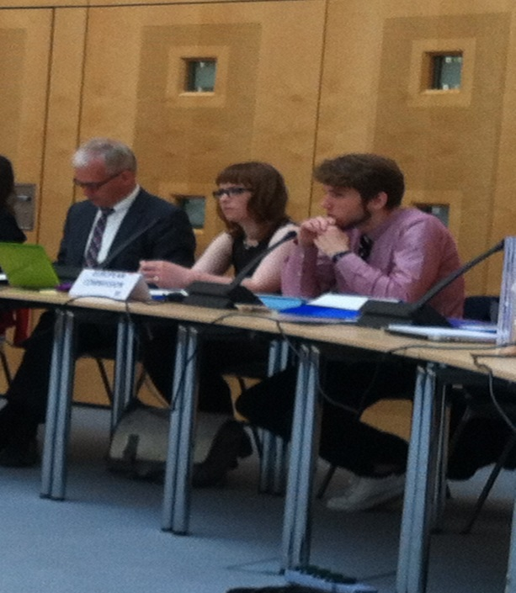
Only the Austrian Minister was not to reassure and continued blocking on a compromise. Even the attempt of the Greek Minister and others to explain in how far the principle of subsidiarity is affected, seemed to fail. “It is still up to the local government to act and to decide, even if there is something like a directive trying to regulate concession contracts” , the German Minister argued. This discussion marked the first day of conference. At the end, the Austrian Minister volunteered to reconsider his point of view and to be, if necessary, open for new suggestions if his initial doubts will be taken into account in further discussions. “I’m looking forward to the following discussions which will become more passionated. We have to take into account all different proposals, ideas and doubts” , Dr. Matthias Wendel concluded.

The second day showed skillfull negotiation and a lot of self-assertation: All Ministers started to debate in formal and as well informal rounds. Informal rounds have been used to build alliances and to succeed in changing some articels being proposed by the European Commission in the existing proposed directive. One of the most discussed issues were Price and Quality Monitoring, the Publical Procedure and the Principle of Subsidiarity. The Austrian proposal to “ […] add the possibility [in the directive] to interprete the Principle of Subsidiarity after the local sense” has been refused by 11 to 6 votes against. Nevertheless, the Austrian Representative tried to bring along such a possibility of interpretation by proposing another recital, being – in the opinion of Estonia – the same as before. ,,We have to come to an end and therefore, we have to accept such a proposal to convince Austria of being in favor of this directive. Otherwise, the directive is useless” , the Greek Minister tried to advance the never-ending debate on Subsidiarity. In the end, the recital has not been passed by an absolute majority. After having clarified this high-explosive issue, the conference was characterized by well-balanced and fast discussions concerning several articles which have been changed partially. The Member Stated showed a high level of willingness to compromise to come to a common proposal of a Concession Directive.

After two days of debating and discussing, all Ministers accepted the new proposal and were relieved having created a directive in which every Member State has manifested his idea of Concession Contracts. “Another success in the development of the European Union” , the European Commission commented on the end of the conference.

